muhammad roshan mughees

193590

Lab 3

Selection Sort:

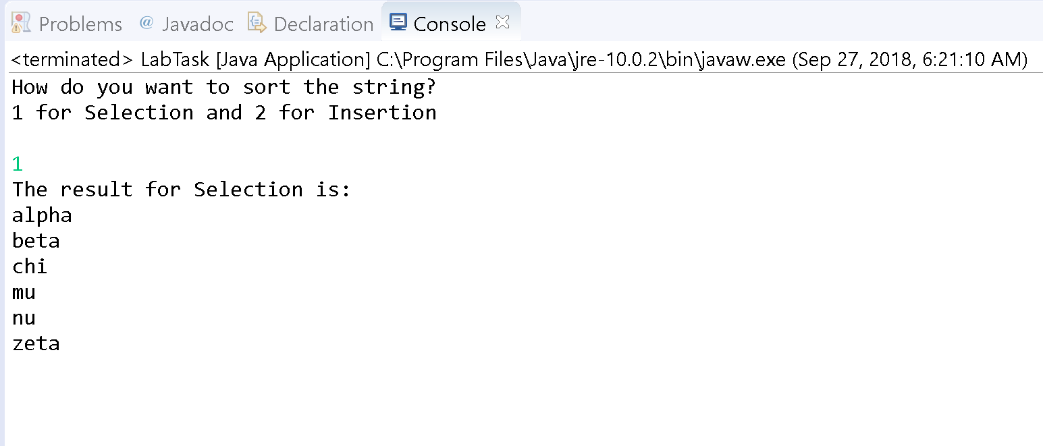

Insertion Sort:

